**What is Express and Why do we use it?**

Writing all that server side logic is pretty complex. We already have seen what we needed to do for parsing an incoming request (listen to different events and work with streams and buffers).

Express helps us with that. It don’t have a built in way of handling or parsing an incoming request data but it makes it easy to install another package that can easily be hooked into our project that will then do the parsing for us.

In general we don’t want to focus on these nitty gritty details but we want to focus on our business logic that defines our applications - unique selling points.

A **framework** basically is a set of helper functions, tools and rules that help you build your application.

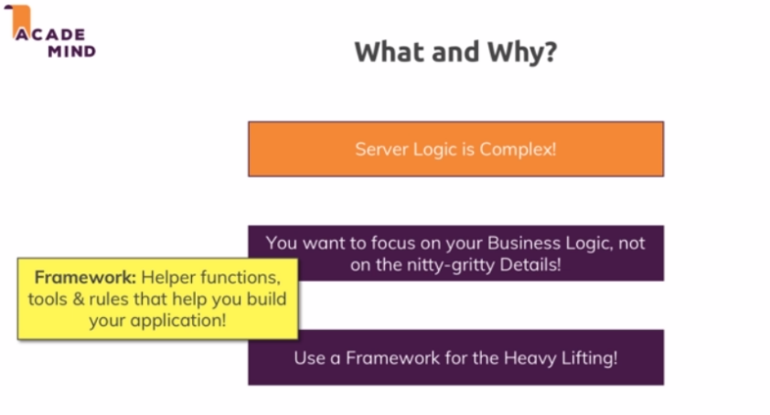

Alternatives of Express

* Vanilla Nodejs
* Adonis.js
* Koa
* Sails.js
* …

**Installing Express.js**

npm install --save express (production dependency)

npm install --save-dev nodemon (development dependency)

**Adding Middleware**

Express is all about middlewares. In the end middleware means that an incoming request is automatically funneled through a bunch of functions by express js.

This is the plug gable nature of express where we can add other third party packages which simply happen to give you such middleware functions that you can plug into express js and add certain functionality.

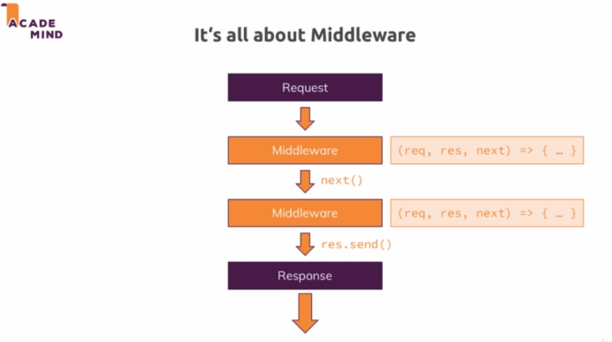

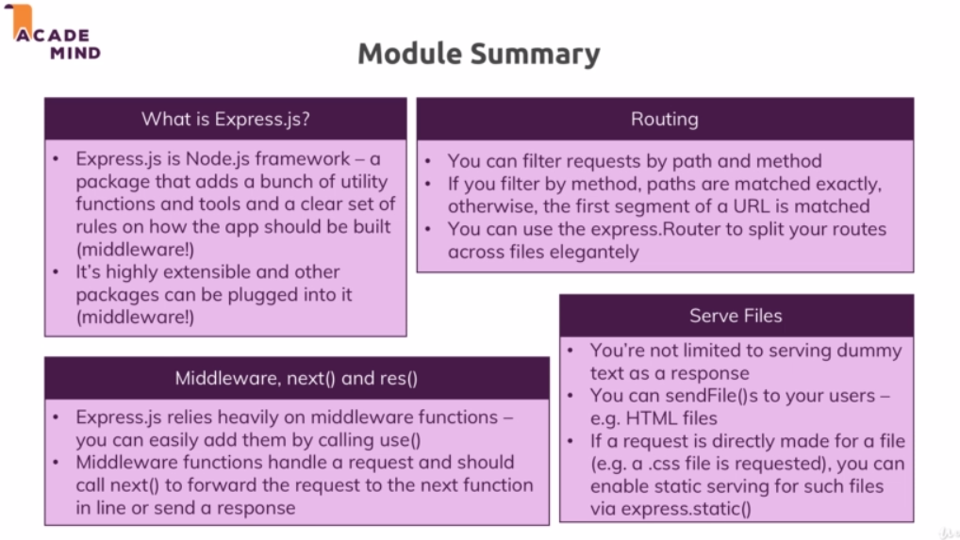

**Useful resources:**

Express.js Official Docs: [https://expressjs.com/en/starter/installing.html](https://expressjs.com/en/starter/installing.html" \t "https://www.udemy.com/course/nodejs-the-complete-guide/learn/lecture/_blank)